## Task 3: [Controling dcMotor (relays](https://github.com/sereen-ba/Controling_dcMotor_relays))

Circuit:

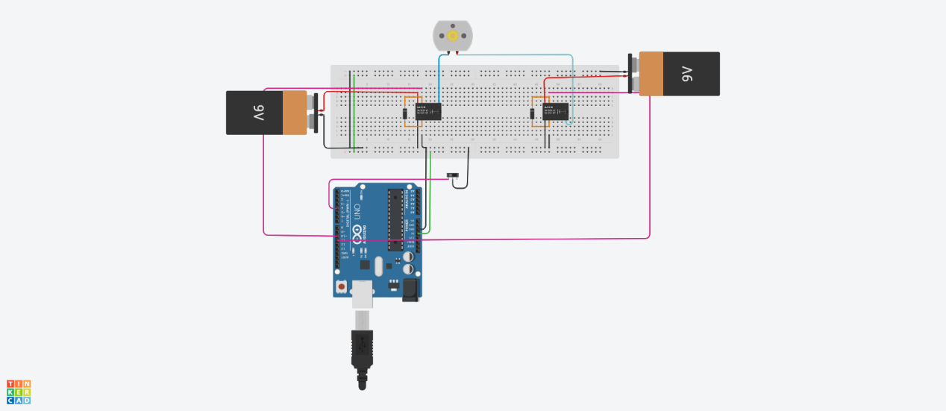

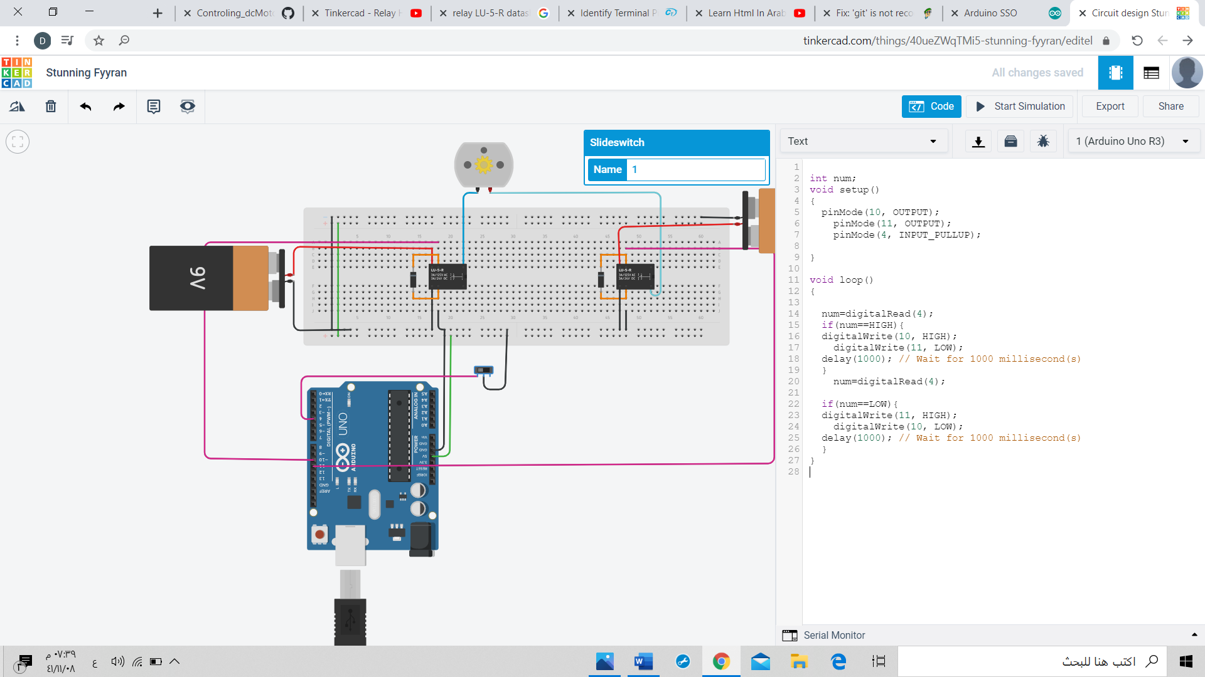Code:

|  |
| --- |
|  |
|  |  |
|  |  |
|  |  |
|  |  |
|  |  |
|  |  |
|  |  |
|  |  |
|  |  |
|  |  |
|  |  |
|  |  |
|  |  |
|  |  |
|  |  |
|  |  |
|  |  |
|  |  |
|  |  |
|  |  |
|  |  |